# Lab 19: HTTP PUT

## Objectives

*  Communicate with a REST API to update data

## Steps

### Communicate with a REST API to update data

1. **Implement** a **method** in the API object to do a **PUT** (update).

#### src\projects\projectAPI.js

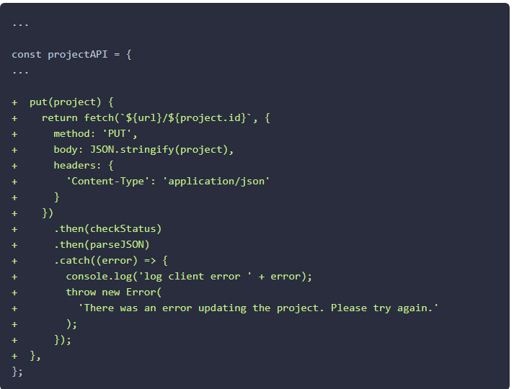

1. **Invoke** the **method** in your container (ProjectsPage) component.

#### src\projects\ProjectsPage.js

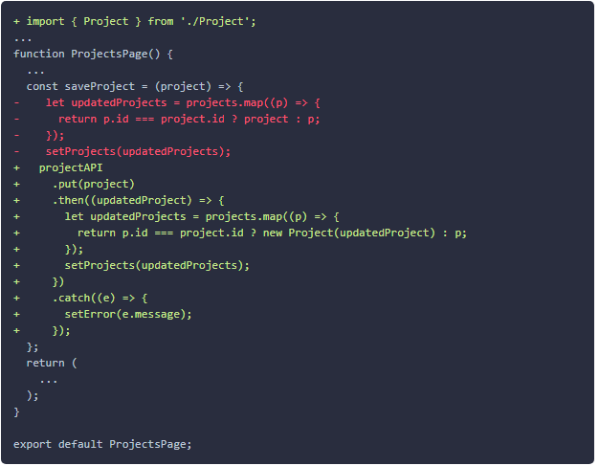

1. **Verify the application is working by following these steps.**
   1. Click the edit button for a project.
   2. Change the project name in the form.
   3. Click the save button on the form.
   4. Verify the card shows the updated data.
   5. Refresh your browser.
   6. Verify the project is still updated.

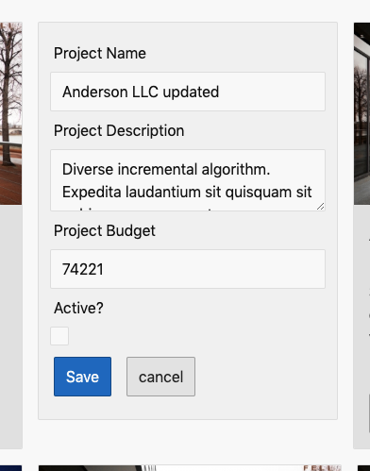

### ✔ You have completed Lab 19